RESULTS AND DISCUSSION
This chapter highlights the CUBIES Game as a finished running system. The Project Description describes the origin of the game and instruction on how to play it. The Project Structure shows the HIPO chart, which shows the hierarchy of important modules included in the system, and User Interface Screenshots also shown here along with some interesting facts in each screen. The Project Capabilities enumerate all the features of the CUBIES Game. And lastly, the Project Evaluation discusses the result of the evaluation procedure conducted by the researchers.

Project Description
The project is all about CUBIES, a 2D mobile game. Some of the rules in this mobile game are adapted from the games Flipull and Tetris. Below is the instruction in playing this mobile game.
Given a randomized cube pattern and a set of cubes to be eliminated, the user must eliminate a number of one or more similar cube patterns for a limited period of time.
If the user accidentally or intentionally hit a cube pattern in a different cube pattern, then his cube pattern will become part of the cubes to be eliminated. He has the freedom to hit a cube in the Sky Platform in order to eliminate similar cube arranged in a column. He also has the option to use a Super Cube to eliminate a line of different cubes arranged in a row or in a column.
In order for him to progress through the game, he must successfully eliminate all cubes before the time runs out. Otherwise, it will mean Game Over.

Project Structure
- HIPO Chart
CUBIES
1.0
New Game
2.0
High Score
3.0
Settings
4.0
Instruction
3.1
Sounds
3.2
Difficulty
3.3
Controls
3.1.1
On
3.1.2
Off
3.2.1
Easy
3.2.2
Normal
3.2.3
Hard
3.3.1
Set A
3.3.2
Set B
3.3.3
Set C
3.3.4
Set D
Figure 16: HIPO Chart of CUBIES: A 2D Mobile Game

- User-Interface Screenshots


Figure 17: Title Screen

This figure shows the very first screen that the user will see upon playing this mobile game. The user has to press any key to be able to go to the Main Menu Screen.
The Title Screen bears the official emblem of the game. It has an inscription CUBIES Version 1.1b, wherein b stands for Beta. The shattered debris on the foreground represents the cube patterns to be eliminated by the user. The symbolic flame on the background represents the Super Cube wherein it can break through any obstacles. Since the Super Cube can eliminate any number of similar or different cubes arranged in either a row or column, then the symbolic flame shows an incredible power in its appearance in the official emblem of the game.

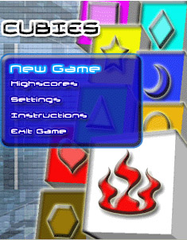
Figure 18: Main Menu Screen

This figure shows the list of menus that are present in the CUBIES Game. It has 5 options namely: New Game, High Scores, Settings, Instructions, and Exit Game. The first 4 options will lead the user to their respective screens whereas the last option will terminate the CUBIES Game.

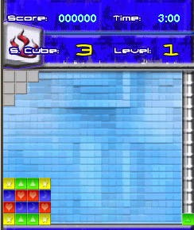
Figure 19: New Game Screen

This figure shows the complete game environment in Level 1 in Normal difficulty. It includes important game information such as score, number of Super Cubes, time remaining, and the current level. It also contains a number of cubes to be eliminated, the Sky Platform, a randomized Base Cube, and the Cube Ladder in which the Base Cube can move up or down.
The first level will be accessible to the user after he selects New Game in the Main Menu Screen. The time, the number of Super Cubes, the number of cubes and its pattern varies depending on the difficulty set by the user in the Settings Screen.
To earn a high score in every level greatly depends on the randomized cube pattern, the time it takes for the user to finish the level and his analytical intuition.

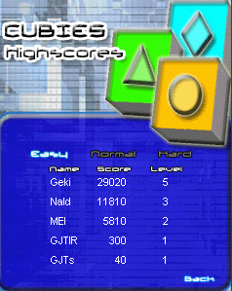
Figure 20: High Scores Screen

This figure appears after the user selects High Scores option in the Main Menu Screen. It lists all top 5 high scorers in each game difficulty. As the user has finished the game and he surpasses any of the current top five high scorers depending on the difficulty, his score will be included in the list depending on his rank and on the difficulty it fits in. By pressing Back, the user will return to the Main Menu Screen.

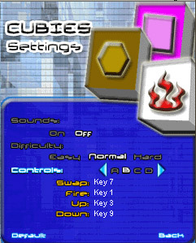
Figure 21: Settings Screen

This figure appears after the user selects the Settings option in the Main Menu Screen. It shows the setting structure of the CUBIES Game. The user can set the sound either on or off. He can also set the difficulty of the game whether it is easy, normal or hard. And he can set the controls whether it is Set A, B, C, or D. If the user wants to restore the game’s original setting, he just needs to press the default button located in the lower-left corner of the screen. In this way, the sound will be set to On, the difficulty will be Normal, and the Controls will be Set A.
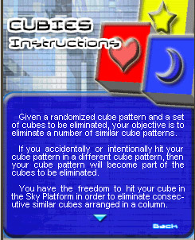
Figure 22: Instructions Screen

This figure appears after the user selects the Instructions option in the Main Menu Screen. It contains a 2-page basic instructions of the game. If the user does not know how to play this game, then he just needs to access this option and read it.

Project Capabilities
The following are the main features that the CUBIES Game has to offer.
- Portability - This mobile game can be run either in J2ME Wireless Toolkit via an emulator of different cellphone brands or he can transfer it directly to his cellphone by using a software suite for the particular cellphone brand he is using.
- Requires MIDP 2.0 and CLDC 1.1 - This mobile game can only be deployed in cellphones that support MIDP 2.0 and CLDC 1.1 such as Nokia models which ranges from Series 60 to 90.
- Different Mode of Gameplay – This mobile game allows the user to set the difficulty from Easy, Normal or Hard depending on his capability in playing the game. The number of Super Cube, cube patterns, and time alloted to finish a level is greatly dependent on the difficulty he sets.
- Customizable Set of Controls – This mobile game allows the user to choose a set of pre-defined controls that he wants.
- Updateable High Score Data – Everytime a user beats any of the current high scorers, then his name code, score, and level will be stored in the High Score Data.
- Turn the Sound On or Off – This mobile game allows the user to turn the sound on or off depending on his preference.

Project Evaluation
The CUBIES Game was evaluated to 40 respondents who gave their opinions and comments regarding the acceptability and quality of the system Regardless as to whether their opinions and comments are positive or negative, it will help in the further improvement of the system.
The 40 respondents are composed of 20 technical experts and 20 end-users. We chose to distribute the evaluation sheet to technical experts, who work in computer-related companies since they are technologically-inclined. Therefore, they can give us a reliable response for the further improvement of our system. While the end-users, who are mostly CCSS Students, will give a good opinion about the basic functionality about the game.
The overall acceptability rate from our respondents for our system is 3.96 which is equivalent to Very Satisfactory. This simply means that the CUBIES Game is complete as a mobile game and our respondents are impressed with the outcome and quality of the system. It also means that the game is open for further improvements to produce an even better version of the game.

Table 2 shows the numerical score given by respondents in each criterion along with their equivalent descriptive meaning.

SOFTWARE CRITERIA | TECHNICAL EXPERTS | END-USERS
  Numerical Rating | Descriptive Rating
  Numerical Rating | Descriptive Rating
A. Installability
- Ease of setting up
  4.05 | Very  Satisfactory
  4.05 | Very  Satisfactory
B. Functionality
- Ease of operation
  4.10 | Very  Satisfactory
  3.65 | Very  Satisfactory
- Provision for comfort and convenience
  4.15 | Very  Satisfactory
  3.85 | Very  Satisfactory
- User-friendliness
  4.25 | Very  Satisfactory
  4.05 | Very  Satisfactory
- Operability
  3.80 | Very  Satisfactory
  4.05 | Very  Satisfactory
C. Reliability
- Conformance to desired result
  4.00 | Very  Satisfactory
  4.00 | Very  Satisfactory
- Accuracy of performance
  4.00 | Very  Satisfactory
  3.90 | Very  Satisfactory
- Absence of failure
  3.85 | Very  Satisfactory
  4.00 | Very  Satisfactory
- Recoverability
  3.60 | Very  Satisfactory
  3.90 | Very  Satisfactory
D. Availability
- Performs according to specification
  3.90 | Very  Satisfactory
  4.10 | Very  Satisfactory
- Completeness of the system
  3.85 | Very  Satisfactory
  4.00 | Very  Satisfactory
E. Maintainability
- Testability
  4.05 | Very  Satisfactory
  3.85 | Very  Satisfactory
- Provision for diagnostic tools and procedures
  3.90 | Very  Satisfactory
  3.55 | Very  Satisfactory

Table 2: Summary of Ratings for CUBIES Game in Each Criterion

Statistical Results of the CUBIES Game
- Frequency Distribution
Table 3 shows all the total score from the 40 respondents who evaluated our system wherein the first 20 are Technical Experts while the later 20 are End-Users. These total scores were taken from each of the Evaluation Instrument answered by them.
Respondent | Total Score
1 | 4.15
2 | 3.95
3 | 4.25
4 | 3.80
5 | 3.80
6 | 3.70
7 | 3.80
8 | 4.20
9 | 3.40
10 | 3.50
11 | 4.25
12 | 4.20
13 | 3.95
14 | 4.00
15 | 4.00
16 | 4.20
17 | 4.10
18 | 4.00
19 | 4.35
20 | 3.65
21 | 4.15
22 | 4.40
23 | 3.80
24 | 3.65
25 | 4.85
26 | 4.10
27 | 3.30
28 | 3.60
29 | 3.65
30 | 4.60
31 | 3.55
32 | 4.15
33 | 3.10
34 | 4.30
35 | 3.50
36 | 3.00
37 | 3.80
38 | 4.70
39 | 3.65
40 | 4.70

Table 3: List of Total Scores from 40 Respondents of the CUBIES Game

The first step in constructing the Frequency Distribution is to get the range, which is the difference between the highest and lowest scores. In the table above, the highest score is 4.85 while the lowest is 3.00. Therefore, the range is 1.85. The next step is to divide the range with its divisible class interval which is 5 to get a class size of 0.37. Lastly to get the Frequency Distribution, tally all the total scores from the table above and get the class mark in each class interval. Table 4 shows its result and the dispersion of total score data.
Class Interval | Frequency | Class Mark
4.49 – 4.85 | 4 | 4.67
4.12 – 4.48 | 11 | 4.30
3.75 – 4.11 | 12 | 3.93
3.38 – 3.74 | 10 | 3.56
3.01 – 3.37 | 2 | 3.19
2.64 – 3.00 | 1 | 2.82
Total | 40

Table 4: Frequency Distribution based from the Evaluation Result of the CUBIES Game

- Frequency Polygon
Finally, for the readers to easily understand and interpret the Frequency Distribution as shown above, convert it into a Frequency Polygon as shown below, wherein the x-axis represents each class mark of total scores while y-axis represents the number of respondents who answered within the class interval in the Evaluation Instrument. Each point in the graph represents the intersection between the class mark and the number of respondents.
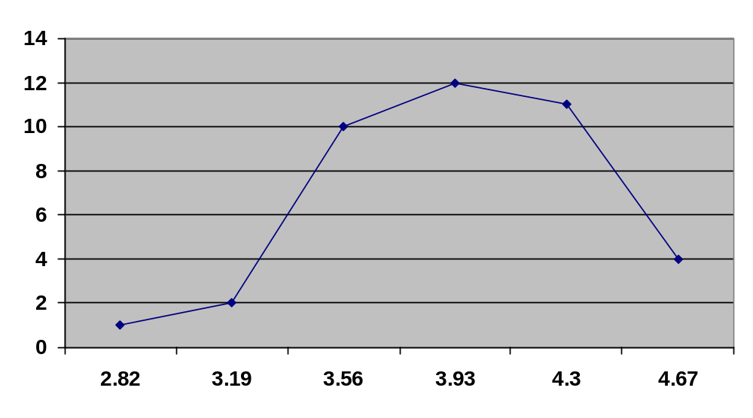
Figure 23: Frequency Polygon based from the Evaluation Result of the CUBIES Game

